Eco Vehicle

Subject:  Related Subjects: | Grade Level(s):  Length of Lesson: | Type: Inquiry / Design / Project  Keywords:

Lesson Overview

Teams will design and construct a two part hybrid vehicle. One part will be the VEX robot. The second part will be the “wind carriage” which will detach from the VEX robot and be wind driven from a prepositioned standard 20 inch box fan.

Lesson Focus
What is the central question or phenomenon being investigated? What problem are they trying to solve?

Lesson Objective(s) | - The team must design and build a two part hybrid vehicle (a combination VEX robot and wind carriage) that accomplishes two tasks:  - Autonomously drive to the Wind Launch Zone and detach wind carriage.  - Retrieve wind carriage in driver (tank) mode and return to Start Zone.  - The team must design and build a wind carriage from any materials which must be solely powered by a 20 inch box fan.  - The wind carriage must have two axles.  - The wind carriage must be in contact with the ground at all times.  - The chassis of the wind carriage must have a minimum size of 25 square inches and a maximum size of 45 square inches.  - NO other energy source may be added to the wind carriage. The wind carriage must be solely powered by the 20 inch box fan.

Lesson Timing

5 minutes | Introduce the Lesson
30 minutes | ...

Materials | - VEX Kit  WIND CARRIAGE:  - Beads, straws, pins for body  - Any materials for sail  - Any materials to assist VEX robot in transporting wind carriage  - May not use any additional stored energy (wind carriage must be solely powered by the 20 inch box fan)
Instructor Prep | - Step 1
Related Resources | - List related lessons/ppts etc available from USC or outside, trusted orgs

Lesson Plan

Introduction
A hybrid vehicle is a vehicle that uses two or more distinct power sources to propel the vehicle. Hybrid vehicles have been in existence since the early 1900s. However, their use had been limited because of consumer interest and development costs. In the early 2000s, fuel costs and concern for the environment gave rise to an interest and demand of these vehicles.

Procedure
Task 1: Drive from Start Zone to Wind Launch Zone and Detach wind carriage

- The hybrid vehicle (combination VEX robot and wind carriage) must autonomously navigate from the Start Zone to the Wind Launch Zone. There will be one stationary obstacle (immovable) between the start zone and the wind launch zone.

- The hybrid vehicle must start within the Start Zone. (See Field Layout)

- Once the hybrid vehicle reaches the Wind Launch Zone and releases the wind carriage, a team member will turn on the fan to the HIGH speed.

  - The front of the wind carriage must start behind the Wind Launch Line.
  - Distance traveled of the wind carriage will be measured from the Wind Launch Line to where the front of the wind carriage stops or leaves the designated Wind Highway. Measurement will be done perpendicular to the Wind Launch Line.

Task 2: Retrieve wind carriage and Return to Start Zone

- Once the wind carriage stops, the fan will be turned off by a team member

- Once the fan is turned off, the VEX robot will retrieve the wind carriage (in driver mode), return to the Wind Launch Zone before driving returning to the Start Zone.

- At no time during the run can team members or spectators enter the designated field area.
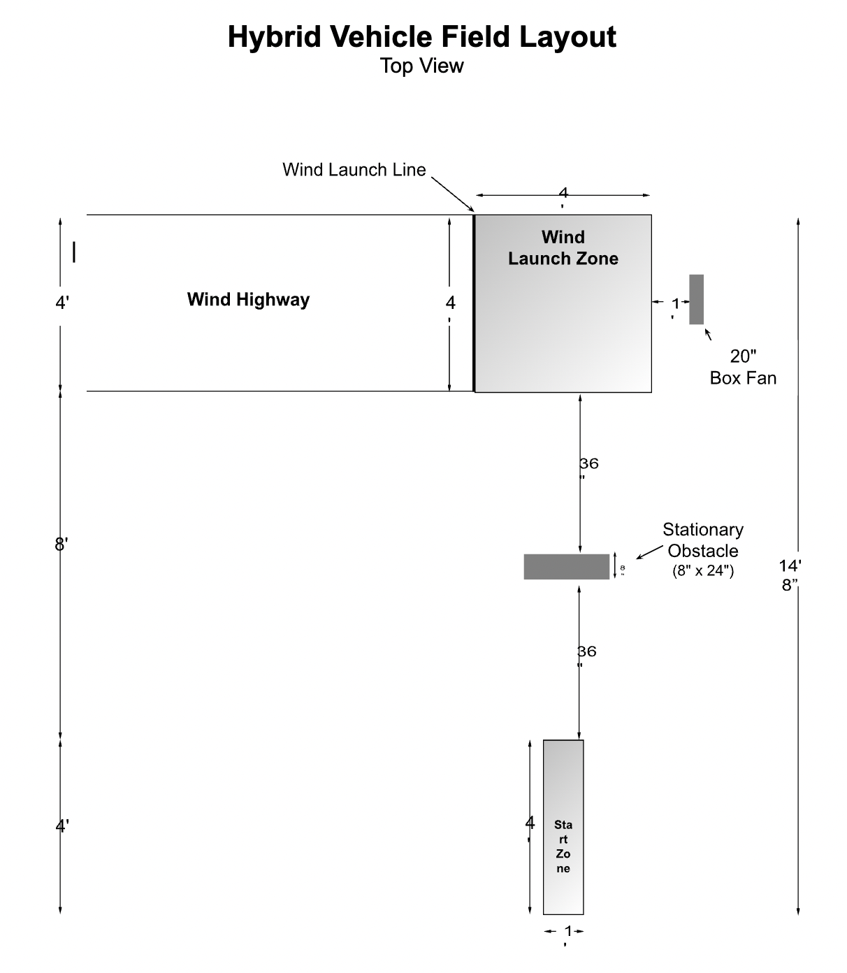

Wrap-up
End the lesson with some final discussions about what students designed/discovered. Connect their activity back to the focus question/problem, real world examples, and STEM careers.

Also include notes about any special cleanup considerations

Lesson Background for Teachers

Suggested Real-World STEM Connections
- List possible related Role Models in STEM (with details and links to more reading). Give suggestions for examples of scientists/engineers who are from underrepresented groups in STEM in related careers.
- List related real-world engineering problems and examples

Lesson Variations and Options
Include descriptions of alternative methods or ways to present things.

Explanation
Describe the background concepts and explanations behind the lesson. This can be more in depth than a teacher/instructor would actually share with students.

Key Concepts and Vocabulary
- Word 1: Grade Appropriate Definition
- Word 2: Grade Appropriate Definition

Safety Notes
- Safety instruction

